Tuesday, 03 March 2020

Dear Parent/Carer

Coronavirus (COVID-19): Advice to parents/carers

I am writing to provide re-assurance to parents and carers about the impact of the coronavirus on the school.

The school continues to receive and follow advice and guidance from the Department for Education and Public Health England, on how to respond to the emerging issues in relation to the coronavirus.

Bury Council and NHS Bury Clinical Commissioning Group have confirmed that the patient in Bury that tested positive for COVD-19 on Sunday has been taken to a specialist NHS infection centre. Understandably, the identification of this case is causing some anxiety amongst parents. There has also been national media coverage of the impact on schools, with a small number of schools in other parts of the country having taken the decision to close as a precaution.

Despite the case in Bury, no further action is required by schools at present, over and above the national guidance and I would like to take this opportunity to confirm there have been no suspected or confirmed cases at Hazel Wood High School at this time.

Public Health England and the office of the Chief Medical Officer are clear in their advice that no school should close in response to a suspected (or confirmed) coronavirus (COVID-19) case unless directed to do so by Public Health England.

However, the advice and guidance to schools is updated regularly to respond to the changing situation and, as a school, we will respond to that advice. The specific national guidance issued in respect of schools is available online at gov.uk. For current local updates, information is available on the Bury Council website by following this link: coronavirus.

The Department for Education has also set up a Coronavirus helpline that parents and carers can contact to answer COVID-19 questions related to education. The helpline number is 0800 046 8687 and is available from 8am to 6pm, Monday to Friday.
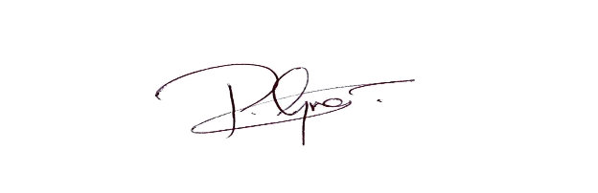
Yours Sincerely,

Mr P Greenhalgh
Headteacher

