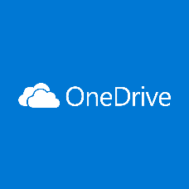 How to use One Drive
LOGGING ON
- Log into the computer
- Google ‘office 365’
- Click on the top link
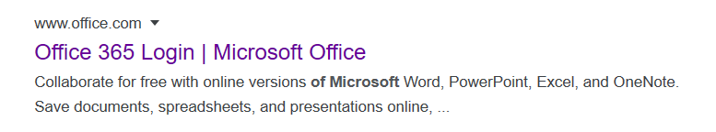
- Put your school login account in the box provided and click next
ie/ usual ICT login username @hazelwoodhigh.co.uk
e.g. lnor@hazelwoodhigh.co.uk
Password is the same as their usual ICT login password
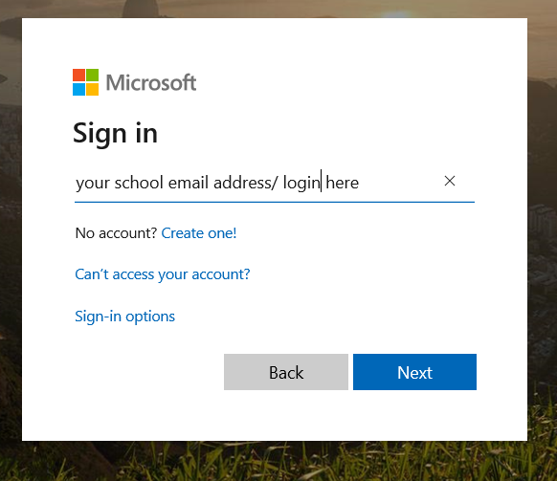

- Enter your password and click sign in

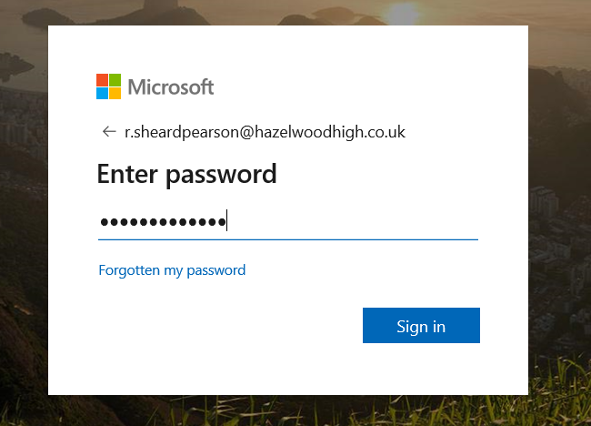

- Stay signed in? Click yes if this is your secure computer. No if this is a public computer.

- You will get this page with all the office icons you can use
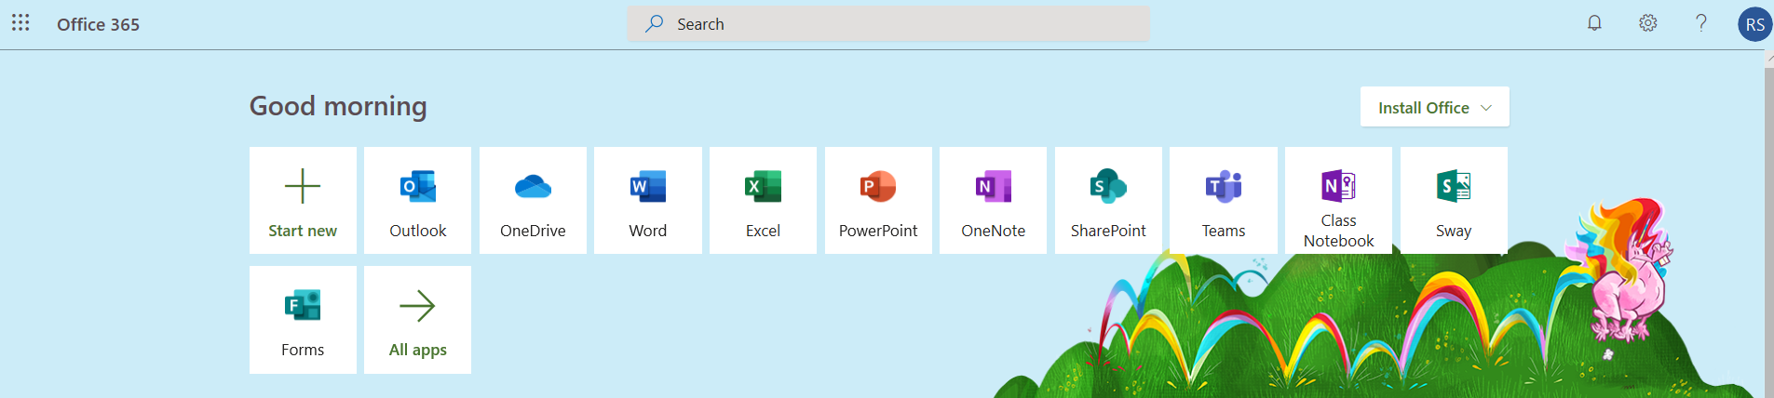
EMAIL
- Outlook is your school email address. You can use this to send work to your teachers. Teachers email addresses are on the website.

- Click the outlook icon. Click on new message (the green box top left) to send an email

- Add your teachers email address in the to box and your name and unit in the subject box. To attach a piece of work click ‘attach’

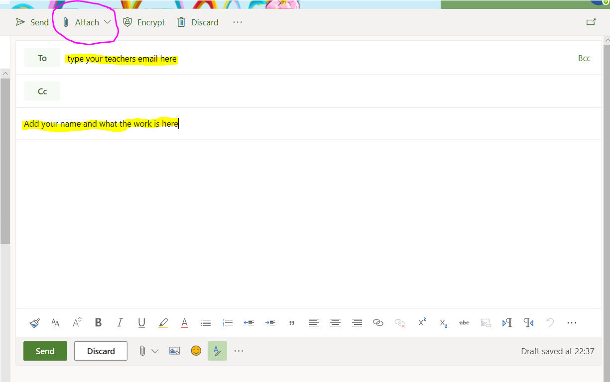

- To look for files saved on your computer click ‘browse this computer.’ To use files saved on your one drive click browse cloud locations. Attach file and send.
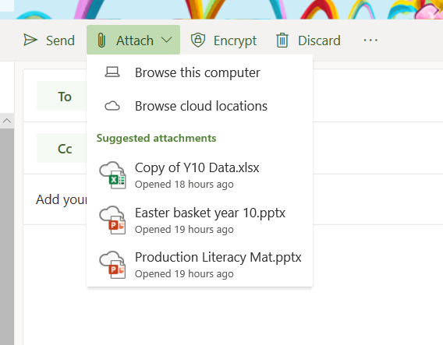

ONE DRIVE

- Click on the OneDrive icon

- To upload files from your computer to save in a central area click upload and follow the instructions it gives you. Your files will be saved centrally in the schools cloud with unlimited storage.
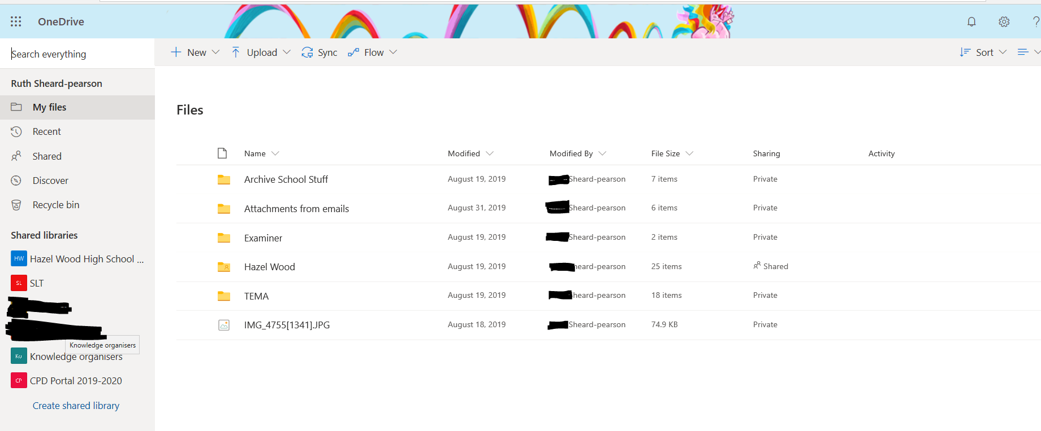
- To share a file with your teacher open the file you want to share and click file in the top left corner
- Click share
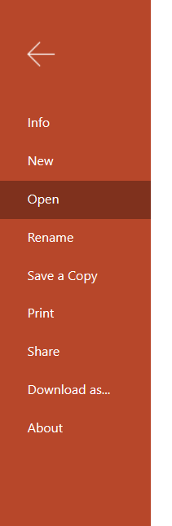

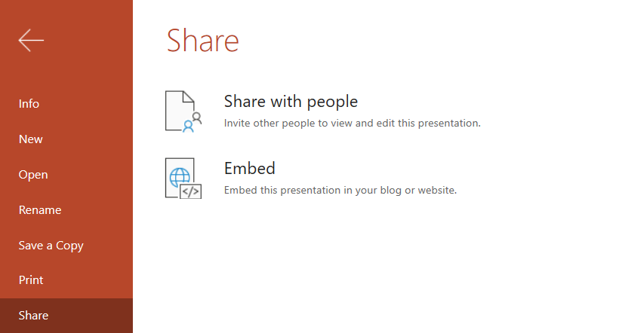

- Type in your teachers name and select from the menu and click send. Your teacher will get an email link of the document. People can share documents with you too. You can click on the email link or click ‘shared’ on the left on the main OneDrive page
